BIBLE PEOPLE
Encounters with Christ in the Scriptures

The Paralytic

PRINCE OF PEACE
LUTHERAN CHURCH
Rev. William A. Schaefer, Pastor
Living, Learning, and Growing in the Word of God

1325 Mission Road, Latrobe, PA 15650
Phone: 724-537-7273
Webpage: www.princeofpeacelatrobe.com
Email: office@princeofpeacelatrobe.com

Welcome come to worship this evening – Throughout the Bible, Jesus encountered people in ordinary and extraordinary way. Throughout the Season of Lent, we will encounter Christ through the quiet introspection of Taizé style worship. This style of worship is based on the repetitive singing of prayerful songs, the reading of scripture and prayer. Take time during these services to look within yourself for where you are being led in faith. Take extra time throughout this season for prayer, scripture and daily devotions that will help you to grow in faith. Listen and hear these stories of our faith and see how they are speaking to you from these witnesses of our faith.
Midweek Lenten Worship
Wednesday, March 9, 2022

Announcements/Prelude

Wait for the Lord (Sung 3 times)
Words and Music: © 1984, Les Presses de Taizé, GIA Publications, Inc., agent. GIA Publications, Inc., agent. Reprinted with permission under ONE LICENSE #A-720198

Come Holy Spirit
2. Come, Word of mercy, …
3. Come, great Creator, …
4. Come to unite us, …
5. Come to inspire us, …

Words and Music: John L. Bell, © 1995 WGRG c/o Iona Community, GIA Publications, Inc., agent. Reprinted with permission under ONE LICENSE #A-720198

CONFESSION AND FORGIVENESS
P Let us confess our sins in the presence of God and one another. Gracious God,
C our sins are too heavy to carry, too real to hide, and too deep to undo. Forgive what our lips tremble to name and what our hearts can no longer bear to hold. Forgive us and set us free from a past that we cannot change; open us to a future in which we can be changed; and grant us grace to grow more and more in your likeness;
through Jesus Christ, our Savior and Lord. Amen
P Through the birth, life, death, burial and resurrection of Our Lord, know that your sins are forgiven. May, the Father, the Son, and the Holy Spirit (+), uphold you in peace.
C Amen.

P The Lord be with you
C And also with you
P Let us pray. O Loving God, to turn away from you is to fall, to turn toward you is to rise, and to stand before you is to abide forever. Grant us, dear Lord, in all that we do you help.; in all our uncertainties your guidance, in all our dangers your protection; and in all our sorrows, your peace; through Jesus Christ our Lord. Amen

Scripture Reading Luke 15:17-26
¹⁷One day, while he was teaching, Pharisees and teachers of the law were sitting nearby (they had come from every village of Galilee and Judea and from Jerusalem); and the power of the Lord was with him to heal. ¹⁸Just then some men came, carrying a paralyzed man on a bed. They were trying to bring him in and lay him before Jesus; ¹⁹but finding no way to bring him in because of the crowd, they went up on the roof and let him down with his bed through the tiles into the middle of the crowd in front of Jesus. ²⁰When he saw their faith, he said, "Friend, your sins are forgiven you." ²¹Then the scribes and the Pharisees began to question, "Who is this who is speaking blasphemies? Who can forgive sins but God alone?" ²²When Jesus perceived their questionings, he answered them, "Why do you raise such questions in your hearts? ²³Which is easier, to say, 'Your sins are forgiven you,' or to say, 'Stand up and walk'? ²⁴But so that you may know that the Son of Man has authority on earth to forgive sins" — he said to the one who was paralyzed — "I say to you, stand up and take your bed and go to your home." ²⁵Immediately he stood up before them, took what he had been lying on, and went to his home, glorifying God. ²⁶Amazement seized all of them, and they glorified God and were filled with awe, saying, "We have seen strange things today."
L The Word of the Lord
C Thanks be to God

Ubi Caritas (Sung 3 times)
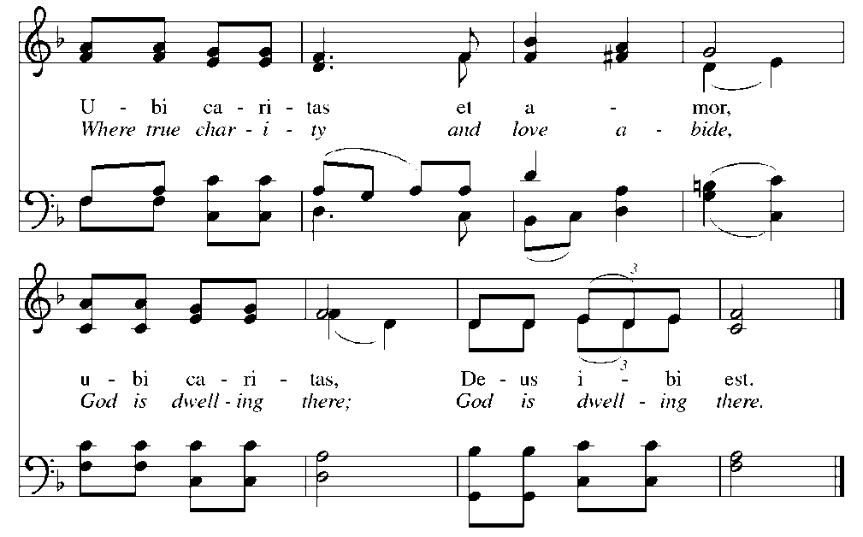
Text and music © 1979 Les Presses de Taizé, GIA Publications, Inc., agent. Reprinted with permission under ONE LICENSE #A-720198
BIBLE PEOPLE: The Paralytic

HYMN Faith Begins By Letting Go

Text: © 1996, Hope Publishing Company Reprinted with permission under ONE LICENSE #A-720198

PRAYERS
After each petition the following refrain is sung by the congregation
P Let us lift our prayers to God. Gracious God, you call us to come to you in prayer for all that we need. Guide us so that we may live according to your Word and inspire us to be your hands in the world. Hear us as we pray to you. (after each petition we will sing the following:)
Words and Music: © 1973, Hope Publishing Company Reprinted with permission under ONE LICENSE #A-720198

P For the many way that you bless us, for food and clothing, house and family, for good government and bountiful harvest, for your grace and life-giving cross. Hear us as we pray to you…

P For those who cry out to you in any need: those who are sick, dying or mourning the loss of a loved one, those who struggle with addiction, those who are unemployed, those who are hungry, those who are alienated from their families and friends, those who live in places where there is war or violence and those who are in need of your love in their lives. We ask that you would bring them your comfort, healing, love and peace. Hear us as we pray to you…

P We give you thanks for hearing us when we pray. We ask your continued love in our lives so that we may always bring our prayers to you. Inspire us by your Holy Spirit to pray always so that we may continue to grow closer to you and serve you through all that we say and do. We ask this through, Jesus Christ, our Savior and Lord.
C Amen

P Lord, remember us in your kingdom and teach us to pray:
C Our Father, who art in heaven,
hallowed be thy name,
thy kingdom come, thy will be done,
on earth as it is in heaven.
Give us this day our daily bread;
and forgive us our trespasses,
as we forgive those
who trespass against us;
and lead us not into temptation,
but deliver us from evil.
For thine is the kingdom,
and the power, and the glory,
forever and ever. Amen.

P May the Lord bless you and keep you. May the Lord’s face shine on you and be gracious to you. May the Lord look upon you with favor and give you peace, in the Name of the Father and of the + Son and of the Holy Spirit.
C Amen

Bless the Lord (sung 3 times)
Words and Music: © 1991, Les Presses de Taizé, GIA Publications, Inc., agent Reprinted with permission under ONE LICENSE #A-720198

Serving our community this evening:
Organist: Garnet Snyder
Reader: Janice Migyanka

The monologues for our services this Lent are taken from Bible People: Monologues for Lent
by Steve Dornbusch. Copyright © 2007 Augsburg Fortress.

Our Lenten Worship Schedule
Wednesdays in Lent
6:00 PM Simple Suppers and Fellowship
7:00 PM Wednesday Lenten Services
March 16 – Peter’s Mother-In-Law
March 23 – Mary Magdalene
March 30 – Thomas
April 6 – Martha
April 13 -- Lazarus

The Great and Holy Week
Maundy Thursday, April 14th at 7:00 PM at POP
Holy Communion and the Stripping of the Altar

Good Friday, April 15th 7:30 PM at POP
The Church will be open throughout Veneration of the Cross
the day for you to come and pray Service of and Tenebrae

Easter Sunday, April 17th
Easter Sunrise Service at 7:00 AM at POP
Festival Service of Easter at 9:00 AM at Trinity
Festival Service of Easter at 10:30 AM at POP

